March Edition
2022

Welcome to the new Wolf Valley News!

Spring is nearly here! Hope you all survived the terrible storms. We woke up to a completely smashed greenhouse. Never mind, I suppose it wasn’t meant to be there. We managed to cut it down in size and turned it into a cold frame instead.

Still looking for new material, articles, thoughts, poems. We hope to include all events locally, some advertising and all upcoming events along with ideas, suggestions, jokes. Please send us all that helps and encourages the community. Regular contributors will be from the Vicar, the Parish Council and local clubs.

This news sheet is supported by your Parish Council for Germansweek and Eworthy and covers those areas and beyond.

All are welcome to be involved. Please send your copy to the editor, details here and on the back page.

Copy deadline is the 25th. day of the month for inclusion in the next month’s issue.

Paper copies to be found in Germansweek Telephone Box, Outside the Dairy in Germansweek, Eworthy Telephone Box (formerly the Scone Box). Online at www.germansweekpc.co.uk or contact: wolfeditor@icloud.com

Germansweek Parish Church:

Message from the Reverend:

In my farming days we often used to sit in the pub and talk bulls, not the BS variety although there was plenty of that as well, but stories of our encounters with bulls. They were nearly always stories of narrow escapes from irate bulls rather than rodeo like tales of daring do. Everyone who has ever worked around bulls has one of these tales, or at least knows someone who has. We passed many an hour recounting how easy it is to leap a five bar gate when being pursued by a ton of angry, snorting bovine.
Although many of the stories were quite comical, like when one chap left the door open to the store shed as he was leaving work and the bull wandered in in search of the feed bags. He had to jump up into the rafters to get out of the way and was still there several hours later and was only discovered when his wife rang the farm because he wasn't down the pub. There was a serious side though, around three farmers are killed by bulls every year in the UK, our stories were not just entertainment down the pub but served as cautionary tales too.
The males of most species tend to be more aggressive than the females, that's nature. Dairy bulls also tend to be more aggressive than beef bulls for some reason. One story that stood out for me was of a farmer who gave his daughter a bull calf to rear for showing. Of course the young girl pampered the calf like a pet, which was fine when it was small but when it was bigger and the testosterone kicked in, coupled with the fact it had no fear of humans because of the way it was reared, it suddenly turned and attacked the young girl leaving her with serious injuries. That's nature and nurture. Even in domesticated animals the wild animal is just under the surface.
We humans aren't any different, we all have a dark primitive side to our being. Look at the atrocities humans can inflict on each other. Even in modern civilised people that part of us is just under the surface. We often wonder how it was that people who have lived together for years can suddenly turn on each in civil war. We like to think we have advanced a bit or it couldn't happen here but look how easily we have divided over Brexit or Covid.
From his time spent in the Siberian prison camps Solzhenitsyn saw it like this:
“Gradually it was disclosed to me that the line separating good and evil passes not through states, nor between classes, nor between political parties either -- but right through every human heart -- and through all human hearts. This line shifts. Inside us, it oscillates with the years and even within hearts overwhelmed by evil, one small bridgehead of good is retained. And even in the best of all hearts, there remains ... an un-uprooted small corner of evil.
Since then I have come to understand the truth of all the religions of the world: They struggle with the evil inside a human being (inside every human being). It is impossible to expel evil from the world in its entirety, but it is possible to constrict it within each person.”
― Aleksandr I. Solzhenitsyn, The Gulag Archipelago 1918–1956

Germansweek Parish Church Services, Notices and Events:

Church Services in March

2nd Ash Wednesday Holy Communion with ashing Lydford 10.00am
Ashing Service Okehampton 7.00pm
6th Lent 1 Holy Communion Germansweek 11.15am
13th Lent 2 No Service
20th Lent 3 Holy Communion Bratton Clovelly 9.30am
27th Lent 4 Evening Prayer Bratton Clovelly 6.00pm

News from RSPB

The RSPB Big Garden Bird Watch

The last weekend in January witnessed the annual RSPB Big Garden Bird Watch. The RSPB ask that you spend an hour counting how many birds of each species visit your garden within a one hour time slot. As a relatively new recruit to this, I armed myself with binoculars, bird book, pen and paper and settled in to a corner of the garden to see who turned up. I have to confess to having a thoroughly enjoyable sixty minutes admiring the beauty of our local birds, their friendships, family rivalries, culinary likes and dislikes and generally good natured behaviours.

First on the scene were the blue tits, no shyness here, straight to the seeds and fat balls, males, females and juveniles in abundance. Friendly, colourful, social birds flitting backwards and forwards around the feeders. They were accompanied by a cohort of great tits with their black caps and broad black band running down their chest, similar in behaviour to the blue tits, busy competing for the feeders. The colourful nuthatch was a true warrior, who during the hour flew several sorties to and from the field boundary a sunflower seed clasped securely in its beak, their distinctive black bandana giving them a somewhat roguish appearance. I also observed coal tits with that distinguishable large white splodge on the back of their heads enjoying the nuts.

Looking to the ground, I witnessed a male and female chaffinch, he with his dusky pink chest - they always emerge from the bushes as a pair, less confident than the excitable blue tits but still busy collecting fallen seeds. Accompanying them on the ground were two pairs of blackbirds, more territorial and easily distracted by a potential threat to domestic harmony. The sturdy wood pigeon meandered between the squabbles, collecting anything that had fallen from the feeders. This turns out to be quite a lot as birds can be very picky when selecting what to eat!

Back up at tree level and I was delighted to see a total of six goldfinches – distinctive cone shaped beak, red brow and beautiful splash of yellow across the wings. I was interested to see that no one messed with the goldfinches. They ensconced themselves on the open bird feeder – totally ignoring some of the special seeds which I was sure they would prefer and proceeded to tuck in. Occasionally, a great tit would venture to the edge but would be given the good news that he wasn’t welcome by a show of fluttering wings.

A welcome sight was the shy marsh tit with his black cap and little black goaty beard beneath his chin and no white on the wing – a lovely little bird. The intelligent, beautiful jay also made an appearance at the edge of the garden but was off in an instant when he spotted me.

There were several other visitors that day – the compact little bullfinch, pied wagtails, starlings (but in small numbers), a crow, three magpies, a pheasant, the ubiquitous robin, two sparrows (or were they meadow pippits) and a greater spotted woodpecker. All in all, it turned out to be quite a party! Assuming I have identified them all correctly, I have to say what a delightful hour spent that was. A small window into the lives of these wonderful creatures, it is fair to say I am hooked. So, for those of you who may not have joined in before, put it on the calendar for 2023. Arm yourself with pen, paper, bird book and a decent pair of binoculars and sit down and enjoy the beauty of birds.

Also……Wildlife wonders!

There are tadpoles galore at Dunsdon Nature Reserve ( Close to the hamlet of Pancrasweek, Nr. Holsworthy EX22 7JW) Hidden between the purple moor grass of the Culm, amphibians are already at the second stage of their life cycle. Wet and wild, this reserve is home to over 180species of flowering pant as well as insects, birds and other wildlife. Soon, butterflies and rare orchids will start to appear bringing oranges and yellows to the landscape. Well worth a visit!

Roadford Rowing Club

February has seen less rowing - mainly due to the high winds - and hope you all survived unscathed from recent storms but especially Eunice!
We were lucky as a club in as much as two of our boats were blown off their racks and ended up on the ground, but thankfully only had minor damage. Phew!
Funding applications are being reviewed and Crowdfunding is up and running, to endeavour to aid a self build boat store project. All of our current boats and equipment are self funded within the club but we do need extra help too!
‘Try Before You Buy’ rowing Taster Sessions are still pencilled in for the Spring and we currently have 7 people on the waiting list - which is great! If anyone wants to join that list, please let me know.
Best wishes and thanks for reading our updates.
Ian
07837 190678

Another fabulous amble. Great route through beautiful forests!
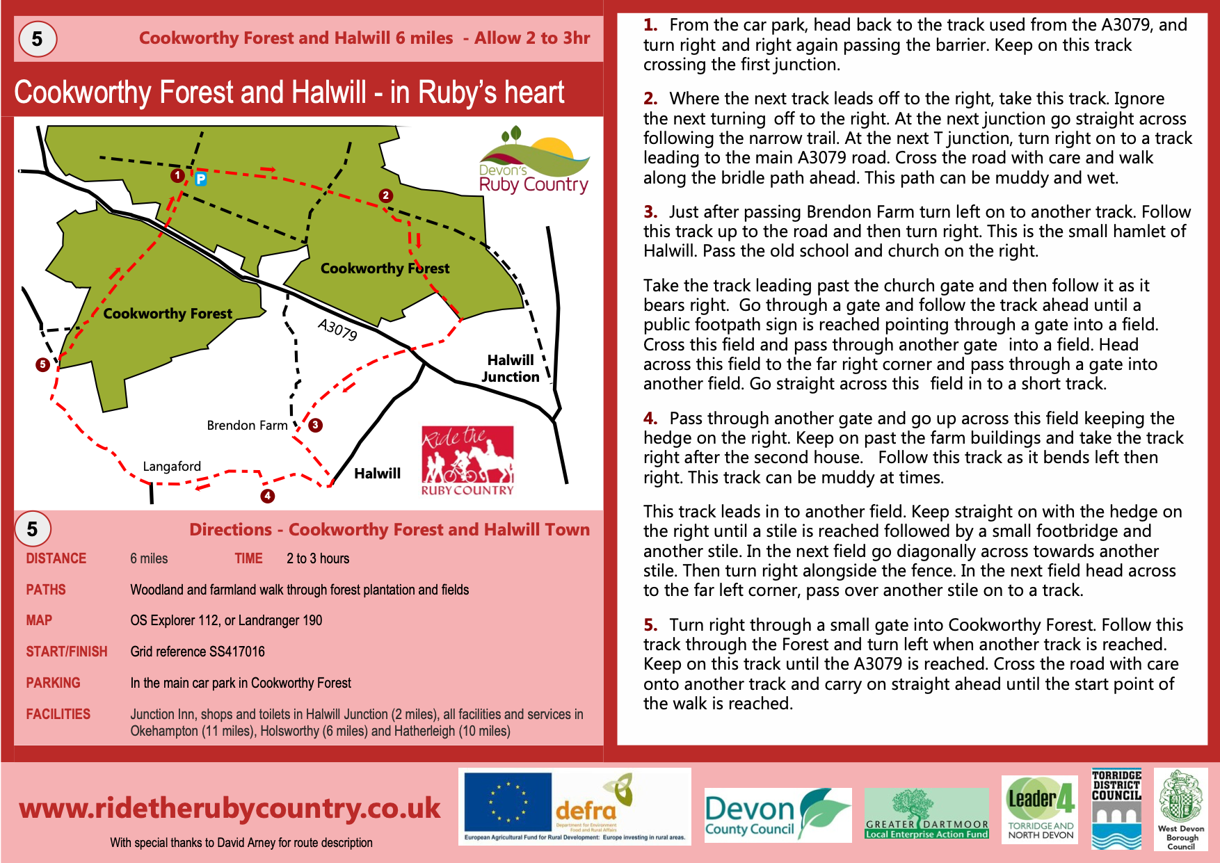

Upcoming/regular events or meetings;

Ivyhouse Garden Club (Broadwood). Please check www.nextdoor.co.uk for the next session . All welcome.

‘Sing along round 2’ hold sessions every month in Germansweek Church.
Germansweek Cribbage Social. Check www.nextdoor.co.uk for updates and meetings.
Much more local information and events can be found on www.nextdoor.co.uk Please take some time to join up and keep up!

Contact Information:

Adrian Brook Parish Vicar 01837 861580

Jackie Theobald Parish Council Chair 01837 871446

Rachel Ward Parish Clerk Crane Cottage, Germansweek, EX21 5BA
germansweekpc@gmail.com

Germansweek Village Hall bookings; contact Eli Collins 01837 871317

Editor: wolfeditor@icloud.com

Please send your copies for inclusion. The deadline is 25th. of every month
Online copies to be found at www.germansweekpc.co.uk under ‘news’ tab

